Strong Winds Strong Roots: What Trees Teach Us About Life

Mar 31, 2015 12:09PM ● By Dennis Merritt Jones (adapted)

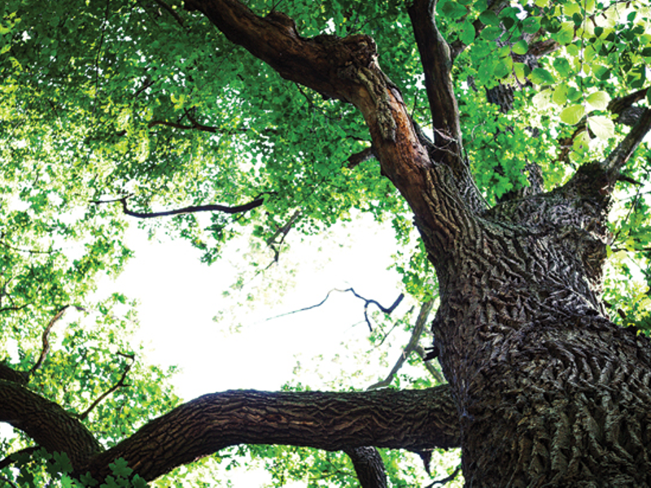

A great experiment in the desert called the biodome created a living environment for human, plant and animal life. A huge glass dome was constructed to house an artificial, controlled environment with purified air and water, healthy soil and filtered light. The intent was to afford perfect growing conditions for trees, fruits and vegetables, as well as humans.

People lived in the biodome, for many months at a time, and everything seemed to do well with one exception. When the trees grew to a certain height, they would topple over. It baffled scientists until they realized they forgot to include the natural element of wind. Trees need wind to blow against them because it causes their root systems to grow deeper, which supports the tree as it grows taller.

Who among us doesn’t long for a perfect growing environment for ourselves, with no disruptions from outside influences? We strive to avoid the times of contrast and tension, when life’s daily challenges push against us. When they do, the normal tendency is to shutter them. If trees could talk, would we hear them curse the wind each time they encountered a storm?

We can learn a great deal from nature’s wisdom at work if we are open to the lesson. Watch how a tree bends and sways gracefully when the wind blows against it. It does not stand rigid, resisting the flow of energy. It does not push back. The tree accepts the strong wind as a blessing that helps it grow.

Such experiences develop our character and deepen our roots. When we grow deep, we too, stand tall.

*Dennis Merritt Jones, D.D., is the author of*Your Re-Defining Moments*,*The Art of Uncertainty*and*The Art of Being*, the source of this essay.*

Dig Deep, Stand Tall, and Give Back. – Tony Fine